Prediction of Fake Job Ad using NLP-based Multilayer Perceptron

ABSTRACT
In modern time, the development in the field of industry and technology has opened a huge opportunity for new and diverse jobs for the job seekers. With the help of the advertisements of these job offers, job seekers find out their options depending on their time, qualification, experience, suitability etc. Recruitment process is now influenced by the power of internet and social media. Since the successful completion of a recruitment process is dependent on its advertisement, the impact of social media over this is tremendous. Social media and advertisements in electronic media have created newer and newer opportunity to share job details. Instead of this, rapid growth of opportunity to share job ads has increased the percentage of fraud job postings which causes harassment to the job seekers. So, people lack in showing interest to new job postings due to preserve security and consistency of their personal, academic, and professional information. Thus, the true motive of valid job postings through social and electronic media faces an extremely hard challenge to attain people’s belief and reliability. Technologies are around us to make our life easy and developed but not to create unsecured environment for professional life. If jobs ads can be filtered properly predicting false job ads, this will be a great advancement for recruiting new employees. Therefore, this project proposed to use different data mining techniques and classification algorithm like K-nearest neighbour, decision tree, support vector machine, naive bayes classifier, random forest classifier, and multi-layer perceptron to predict a job Advertisement if it is real or fraudulent. We have experimented on Employment Scam Aegean Dataset (EMSCAD) containing 18000 samples. Deep neural network as a classifier, performs great for this classification task. We have used three dense layers for this deep neural network classifier. The trained classifier shows approximately 98% classification accuracy (DNN) to predict a fraudulent job ad.
Keywords: fake job prediction, machine learning, neural networks, deep neural networks

CHAPTER 1
INTRODUCTION
1.1 AIM OF THE PROJECT
Data Collection and Preprocessing: Acquire a comprehensive dataset containing both authentic and deceptive job advertisements. Clean and preprocess the data, addressing issues such as missing values, irrelevant information, and standardizing the text format. Feature Extraction and Representation: Utilize NLP techniques to extract relevant features from the job descriptions, such as word frequency, sentiment analysis, and linguistic patterns. Transform the textual data into a suitable numerical representation, considering methods like TF-IDF (Term Frequency-Inverse Document Frequency) or word embeddings.
1.2 OBJECTIVE OF THE PROJECT
Data Acquisition and Compilation: Gather a diverse and representative dataset comprising both authentic and deceptive job advertisements. Ensure the dataset encompasses various industries, job roles, and linguistic patterns to enhance the model's generalization. Data Preprocessing: Conduct thorough data cleaning and preprocessing to handle any noise, inconsistencies, or irrelevant information in the dataset. Standardize the format of textual data, addressing issues such as spelling errors, abbreviations, and variations in language.
1.3 SCOPE OF THE PROJECT
Data Collection and Compilation: Acquire a diverse dataset encompassing both authentic and deceptive job advertisements from various sources and industries. Ensure the dataset reflects the linguistic diversity and patterns found in real-world job postings. Data Preprocessing: Conduct comprehensive data cleaning and preprocessing to handle inconsistencies, noise, and irrelevant information in the dataset. Standardize and format textual data to enhance the effectiveness of subsequent NLP techniques.
1.4 Introduction
In modern time, the development in the field of industry and technology has opened a huge opportunity for new and diverse jobs for the job seekers. With the help of the advertisements of these job offers, job seekers find out their options depending on their time, qualification, experience, suitability etc. Recruitment process is now influenced by the power of internet and social media.
Since the successful completion of a recruitment process is dependent on its advertisement, the impact of social media over this is tremendous [1]. Social media and advertisements in electronic media have created newer and newer opportunity to share job details. Instead of this, rapid growth of opportunity to share job posts has increased the percentage of fraud job postings which causes harassment to the job seekers.
So, people lack in showing interest to new job postings due to preserve security and consistency of their personal, academic and professional information. Thus, the true motive of valid job postings through social and electronic media faces an extremely hard challenge to attain people’s belief and reliability. Technologies are around us to make our life easy and developed but not to create unsecured environment for professional life. If jobs posts can be filtered properly predicting false job posts, this will be a great advancement for recruiting new employees. . Fake job posts create inconsistency for the job seeker to find their preferable jobs causing a huge waste of their time. An automated system to predict false job post opens a new window to face difficulties in the field of Human Resource Management [2].
1.5 Fake Job Posting
Job Scam Online job advertisements which are fake and mostly willing to steal personal and professional information of job seekers instead of giving right jobs to them is known as job scam. Sometimes fraudulent people try to gather money illegally from job seekers. A recent survey by ActionFraud from UK has shown that more than 67% people are at great risk who look for jobs through online advertisements but unaware of fake job posts or job scam. In UK, almost 700000 job seekers complained to lose over $500000 being a victim of job scam.
The report showed almost 300% increase over the last two years in UK. Students, fresh graduates are being mostly targeted by the frauds as they usually try to get a secured job for which they are willing to pay extra money. Cybercrime avoidance or protection techniques fail to decrease this offence since frauds change their way of job scam very frequently [3].
1.6 Common types of Job Scam
Fraudsters who want to gain other people’s personal information like insurance details, bank details, income tax details, date of birth, national id create fake job advertisements. Advance fee scams occur when frauds ask for money showing reasons like admin charges, information security checking cost, management cost etc. Sometimes fraudsters act them- selves as employers and ask people about passport details, bank statements, driving license etc. as pre-employment check.
Illegal money mulling scams occur when they convince students to pay money into their accounts and then transfer it back [4]. This ’cash in hand’ technique causes to work cash in hand without paying any tax. Scammers usually create fake company websites, clone bank websites, clone official looking documents etc. to trap job seekers. Most of the job scammers try to trap people through email rather than face to face communication. They usually target social media like Linkedln to prove themselves as recruitment agencies or headhunters.
They usually try to represent their company profile or websites to the job seeker as realistic as possible. Whatever the type of job scam they use, the always target the job seeker to fall in their trap, collecting information and making benefit either earning money or any other things. Employment scam is one of the serious issues in recent times addressed in the domain of Online Recruitment Frauds (ORF).
In recent days, many companies prefer to post their vacancies online so that these can be accessed easily and timely by the job-seekers. However, this intention may be one type of scam by the fraud people because they offer employment to job-seekers in terms of taking money from them. Fraudulent job advertisements can be posted against a reputed company for violating their credibility.
These fraudulent job post detection draws a good attention for obtaining an automated tool for identifying fake jobs and reporting them to people for avoiding application for such jobs. For this purpose, machine learning approach is applied which employs several classification algorithms for recognizing fake posts. In this case, a classification tool isolates fake job posts from a larger set of job advertisements and alerts the user.
To address the problem of identifying scams on job posting, supervised learning algorithm as classification techniques are considered initially. A classifier maps input variable to target classes by considering training data. Classifiers addressed in the paper for identifying fake job posts from the others are described briefly. These classifiers-based prediction may be broadly categorized into -Single Classifier based Prediction and Ensemble Classifiers based Prediction.
1.5 Machine Learning
Machine learning (ML) is a type of artificial intelligence (AI) that allows software applications to become more accurate at predicting outcomes without being explicitly programmed to do so. Machine learning algorithms use historical data as input to predict new output values.
Recommendation engines are a common use case for machine learning. Other popular uses include fraud detection, spam filtering, malware threat detection, business process automation (BPA) and Predictive maintenance.
1.5.1 Important of machine learning
Why is machine learning important?
Machine learning is important because it gives enterprises a view of trends in customer behavior and business operational patterns, as well as supports the development of new products. Many of today's leading companies, such as Facebook, Google and Uber, make machine learning a central part of their operations. Machine learning has become a significant competitive differentiator for many companies.
1.5.2 Types of machine learning
What are the different types of machine learning?
Classical machine learning is often categorized by how an algorithm learns to become more accurate in its predictions. There are four basic approaches: supervised learning, unsupervised learning, semi-supervised learning and reinforcement learning. The type of algorithm data scientists chooses to use depends on what type of data they want to predict.
1.5.2.1 Supervised learning:
In this type of machine learning, data scientists supply algorithms with labeled training data and define the variables they want the algorithm to assess for correlations. Both the input and the output of the algorithm is specified.
1.5.2.2 Unsupervised learning:
This type of machine learning involves algorithms that train on unlabeled data. The algorithm scans through data sets looking for any meaningful connection. The data that algorithms train on as well as the predictions or recommendations they output are predetermined.
1.5.2.3 Semi-supervised learning:
This approach to machine learning involves a mix of the two preceding types. Data scientists may feed an algorithm mostly labeled training data, but the model is free to explore the data on its own and develop its own understanding of the data set.
1.5.2.4 Reinforcement learning:
Data scientists typically use reinforcement learning to teach a machine to complete a multi-step process for which there are clearly defined rules. Data scientists program an algorithm to complete a task and give it positive or negative cues as it works out how to complete a task. But for the most part, the algorithm decides on its own what steps to take along the way.
1.5.3 Supervised machine learning work
How does supervised machine learning work? Supervised machine learning requires the data scientist to train the algorithm with both labeled inputs and desired outputs.
Supervised learning algorithms are good for the following tasks:
Binary classification: Dividing data into two categories.
Multi-class classification: Choosing between more than two types of answers.
Regression modeling: Predicting continuous values.
Ensembling: Combining the predictions of multiple machine learning models to produce an accurate prediction.
1.5.4 Unsupervised machine learning work
How does unsupervised machine learning work?
Unsupervised machine learning algorithms do not require data to be labeled. They sift through unlabeled data to look for patterns that can be used to group data points into subsets.
Most types of deep learning, including neural networks, are unsupervised algorithms. Unsupervised learning algorithms are good for the following tasks:
Clustering: Splitting the dataset into groups based on similarity.
Anomaly detection: Identifying unusual data points in a data set.
Association mining: Identifying sets of items in a data set that frequently occur together.
Dimensionality reduction: Reducing the number of variables in a data set.
How does semi-supervised learning work?
Semi-supervised learning works by data scientists feeding a small amount of labeled training data to an algorithm. From this, the algorithm learns the dimensions of the data set, which it can then apply to new, unlabeled data. The performance of algorithms typically improves when they train on labeled data sets. But labeling data can be time consuming and expensive.
Semi-supervised learning strikes a middle ground between the performance of supervised learning and the efficiency of unsupervised learning. Some areas where semi-supervised learning is used include:
Machine translation: Teaching algorithms to translate language based on less than a full dictionary of words.
Fraud detection: Identifying cases of fraud when you only have a few positive examples.
Labelling data: Algorithms trained on small data sets can learn to apply data labels to larger sets automatically.
How does reinforcement learning work?
Reinforcement learning works by programming an algorithm with a distinct goal and a prescribed set of rules for accomplishing that goal. Data scientists also program the algorithm to seek positive rewards -- which it receives when it performs an action that is beneficial toward the ultimate goal -- and avoid punishments -- which it receives when it performs an action that gets it farther away from its ultimate goal.
Reinforcement learning is often used in areas such as:
Robotics: Robots can learn to perform tasks the physical world using this technique.
Video gameplay: Reinforcement learning has been used to teach bots to play a number of video games.
Resource management: Given finite resources and a defined goal, reinforcement learning can help enterprises plan out how to allocate resources.
1.5.5 Using machine learning
Today, machine learning is used in a wide range of applications. Perhaps one of the most well-known examples of machine learning in action is the recommendation engine that powers Facebook's news feed. Facebook uses machine learning to personalize how each member's feed is delivered.
If a member frequently stops to read a particular group's posts, the recommendation engine will start to show more of that group's activity earlier in the feed. Behind the scenes, the engine is attempting to reinforce known patterns in the member's online behavior. Should the member change patterns and fail to read posts from that group in the coming weeks, the news feed will adjust accordingly.
Customer relationship management. CRM software can use machine learning models to analyze email and prompt sales team members to respond to the most important messages first. More advanced systems can even recommend potentially effective responses.
Business intelligence. BI and analytics vendors use machine learning in their software to identify potentially important data points, patterns of data points and anomalies.
Human resource information systems. HRIS systems can use machine learning models to filter through applications and identify the best candidates for an open position.
Self-driving cars. Machine learning algorithms can even make it possible for a semi-autonomous car to recognize a partially visible object and alert the driver.
Virtual assistants. Smart assistants typically combine supervised and unsupervised machine learning models to interpret natural speech and supply context.
1.5.6 Advantages and Disadvantages of machine learning
Machine learning has seen use cases ranging from predicting customer behavior to forming the operating system for self-driving cars. When it comes to advantages, machine learning can help enterprises understand their customers at a deeper level. By collecting customer data and correlating it with behaviors over time, machine learning algorithms can learn associations and help teams tailor product development and marketing initiatives to customer demand.
Some companies use machine learning as a primary driver in their business models. Uber, for example, uses algorithms to match drivers with riders. Google uses machine learning to surface the ride advertisements in searches. But machine learning comes with disadvantages. First and foremost, it can be expensive. Machine learning projects are typically driven by data scientists, who command high salaries.
These projects also require software infrastructure that can be expensive. There is also the problem of machine learning bias. Algorithms trained on data sets that exclude certain populations or contain errors can lead to inaccurate models of the world that, at best, fail and, at worst, are discriminatory. When an enterprise bases core business processes on biased models it can run into regulatory and reputational harm.
1.5.7 future of machine learning
While machine learning algorithms have been around for decades, they've attained new popularity as artificial intelligence has grown in prominence. Deep learning models, in particular, power today's most advanced AI applications.
Machine learning platforms are among enterprise technology's most competitive realms, with most major vendors, including Amazon, Google, Microsoft, IBM and others, racing to sign customers up for platform services that cover the spectrum of machine learning activities, including data collection, data preparation, data classification, model building, training and application deployment.
As machine learning continues to increase in importance to business operations and AI becomes more practical in enterprise settings, the machine learning platform wars will only intensify. Continued research into deep learning and AI is increasingly focused on developing more general applications.
Today's AI models require extensive training in order to produce an algorithm that is highly optimized to perform one task. But some researchers are exploring ways to make models more flexible and are seeking techniques that allow a machine to apply context learned from one task to future, different tasks.
1.6 Deep Learning
1.6.1 Deep Learning:
Deep learning is a subset of machine learning that focuses on training deep neural networks with multiple layers to learn and represent complex patterns in data. Deep neural networks are composed of interconnected layers of artificial neurons that simulate the structure and functioning of the human brain.
Deep learning is a branch of machine learning which is based on artificial neural networks. It is capable of learning complex patterns and relationships within data. In deep learning, we don’t need to explicitly program everything. It has become increasingly popular in recent years due to the advances in processing power and the availability of large datasets.
Because it is based on artificial neural networks (ANNs) also known as deep neural networks (DNNs). These neural networks are inspired by the structure and function of the human brain’s biological neurons, and they are designed to learn from large amounts of data.
1.6.2 Key aspects of deep learning include:
- Neural Networks: Deep learning relies on neural networks with multiple hidden layers, allowing the network to learn hierarchical representations of the data. Each layer in the network extracts higher-level features from the representations learned in the previous layer. Deep neural networks can automatically learn and extract relevant features from raw data, eliminating the need for manual feature engineering.
- Training Process: Deep learning models are trained through a process called back propagation, where the network adjusts its internal parameters (weights and biases) to minimize the difference between the predicted output and the target output. This process involves propagating errors backward through the network and updating the parameters using gradient descent optimization algorithms.
- Large-Scale Data: Deep learning models typically require a large amount of labeled data for training. The availability of big data and advances in computing power have enabled the success of deep learning models. The large-scale data allows deep neural networks to learn complex representations and generalize well to new, unseen data.
- Applications: Deep learning has shown remarkable performance in various fields, including computer vision, natural language processing, speech recognition, and recommendation systems. It has achieved state-of-the-art results in tasks such as image classification, object detection, machine translation, and speech synthesis.
- Deep learning excels in handling complex and high-dimensional data, capturing intricate patterns, and achieving state-of-the-art performance in many AI tasks. However, it typically requires more computational resources and data compared to traditional machine learning approaches.
In summary, machine learning focuses on training algorithms to learn patterns and make predictions or decisions, while deep learning is a specific approach within machine learning that utilizes deep neural networks to learn complex representations. Deep learning has gained significant attention and has been particularly successful in solving tasks that involve complex data such as images, audio, and text.
Lane detection using deep learning is a popular approach that leverages the power of deep neural networks to detect and track lane markings on the road. Deep learning models excel in learning complex patterns and can effectively capture the distinctive characteristics of lane markings, making them well-suited for this task. Here is a high-level overview of the lane detection process using deep learning:
- Dataset Preparation: The first step is to collect or create a dataset of labeled images or videos, where the lane markings are manually annotated. The annotations typically involve marking the pixels or regions corresponding to the lane markings in the images or videos.
- Data Pre-processing: The collected dataset is pre-processed to prepare it for training. This may involve resizing the images, normalizing pixel values, and splitting the dataset into training and validation sets.
- Model Architecture: A deep learning model architecture needs to be selected or designed for lane detection. Convolutional Neural Networks (CNNs) are commonly used due to their ability to capture spatial dependencies in images. The model architecture may consist of multiple convolutional layers followed by pooling, fully connected layers, and output layers.
- Training: The deep learning model is trained using the labeled dataset. The training process involves feeding the input images into the model, comparing the predicted output (lane markings) with the ground truth annotations, and updating the model's weights through back propagation and gradient descent optimization algorithms. The objective is to minimize the difference between the predicted output and the ground truth annotations.
- Post-processing: Once the model is trained, the lane detection results may undergo post-processing steps to refine the detected lane markings. This may include techniques such as filtering outliers, curve fitting, and extrapolation to extend the detected lanes.
- Evaluation and Testing: The trained model is evaluated on a separate test dataset to assess its performance. Evaluation metrics such as accuracy, precision, recall, and F1 score can be used to measure the model's lane detection performance.
- Deployment: The trained lane detection model can be deployed in real-time applications, such as autonomous vehicles or advanced driver-assistance systems (ADAS), to detect and track lane markings in real-world scenarios.
It's worth noting that there are different variations and approaches for lane detection using deep learning, including single-image-based methods and video-based methods. Additionally, techniques like semantic segmentation and instance segmentation can also be employed to precisely detect and differentiate lane markings from other objects on the road.
Deep learning-based lane detection has shown promising results and has been successfully applied in various real-world applications. However, it's important to fine-tune and validate the model on diverse datasets and consider factors such as different weather conditions, road types, and lighting variations to ensure robust and reliable lane detection performance.
1.6.3 Application of Deep learning
Deep learning is a subset of machine learning that uses artificial neural networks (ANNs) to model and solve complex problems. It is based on the idea of building artificial neural networks with multiple layers, called deep neural networks, that can learn hierarchical representations of the data.
Deep learning algorithms use a layered architecture, where the input data is passed through an input layer and then propagated through multiple hidden layers, before reaching the output layer. Each layer applies a set of mathematical operations, called weights and biases, to the input data, and the output of one layer serves as the input to the next.
The process of training a deep learning model involves adjusting the weights and biases of the model to minimize the error between the predicted output and the true output. This is typically done using a variant of gradient descent, an optimization algorithm that adjusts the weights and biases in the direction of the steepest decrease in the error.
Deep learning has a wide range of applications, including image and speech recognition, natural language processing, and computer vision. One of the main advantages of deep learning is that it can automatically learn features from the data, which means that it doesn’t require the features to be hand-engineered. This is particularly useful for tasks where the features are difficult to define, such as image recognition.

1.6.4 Advantages of Deep Learning:
Deep learning has several advantages over traditional machine learning methods, some of the main ones include:
- Automatic feature learning: Deep learning algorithms can automatically learn features from the data, which means that they don’t require the features to be hand-engineered. This is particularly useful for tasks where the features are difficult to define, such as image recognition.
- Handling large and complex data: Deep learning algorithms can handle large and complex datasets that would be difficult for traditional machine learning algorithms to process. This makes it a useful tool for extracting insights from big data.
- Improved performance: Deep learning algorithms have been shown to achieve state-of-the-art performance on a wide range of problems, including image and speech recognition, natural language processing, and computer vision.
- Handling non-linear relationships: Deep learning can uncover non-linear relationships in data that would be difficult to detect through traditional methods.
- Handling structured and unstructured data: Deep learning algorithms can handle both structured and unstructured data such as images, text, and audio.
- Predictive modeling: Deep learning can be used to make predictions about future events or trends, which can help organizations plan for the future and make strategic decisions.
- Handling missing data: Deep learning algorithms can handle missing data and still make predictions, which is useful in real-world applications where data is often incomplete.
- Handling sequential data: Deep learning algorithms such as Recurrent Neural Networks (RNNs) and Long Short-term Memory (LSTM) networks are particularly suited to handle sequential data such as time series, speech, and text. These algorithms have the ability to maintain context and memory over time, which allows them to make predictions or decisions based on past inputs.
- Scalability: Deep learning models can be easily scaled to handle an increasing amount of data and can be deployed on cloud platforms and edge devices.
- Generalization: Deep learning models can generalize well to new situations or contexts, as they are able to learn abstract and hierarchical representations of the data.

CHAPTER 2
LITERATURE SURVEY
Habiba et al. [1] proposed to predict if a job posting is real or fraudulent using different classification algorithms and data mining techniques like DNN, multilayer perceptron, RF classifiers, NB classifiers, SVM, DT, and KNN. On the Employment Scam Aegean Dataset (EMSCAD), we have examined 18000 samples. DNN performs great classifier in classification step. For this deep neural network classifier we have used three dense layers. The trained classifier shows 98% classification accuracy to predict a fraudulent job post. [1]
Amaar et al. [2] proposed to analyze whether these job ads are real or fraudulent using six machine learning models. Fake job advertisements are a famous scam. For these fake job openings, people apply, waste their money, send their data to scammers, and pay application fees to scammers. From online recruitment portals to detecting fraudulent job ads, we proposed a methodology that NLP and supervised ML techniques. To analyze the overall performance of the classifiers, we compared all models with both TF-IDF and BoW features. In this study, one of the challenges is the dataset we used. The model over fitted the majority of class data due to an unbalanced ratio of fake and real job posting samples. By using TF-IDF as feature extraction and ADASYN as oversampling, ETC achieved 99.9% accuracy through experimental analysis.
Mehboob et al. [3] tackle the scam or fraud detection problem in the recruitment. In this paper, various important features of organisations, types of compensation, and job descriptions are proposed. An effective recruitment fraud detection model using the extreme gradient boosting method is constructed. It creates an algorithm that extracts the necessary components from job advertisements and tests it with three samples. For a two-step feature selection strategy, the features are further considered. Selected characteristics combined into a hybrid composition showed 97.94% accuracy and outperformed three state-of-the-art baselines. The most effective indicators the study finds are “organization_type,” “company_profile,” "salary_range," has multiple jobs,” and “required education."
Ranparia et al. [4] used machine learning to minimize the number of such frauds and predict fake jobs so that students can stay alert and, if required, take informed decisions. In the job posting to analyse the pattern and sentiments, the model will use NLP. As a SNN the model will be trained and the Glove algorithm used. To predict jobs posted on LinkedIn, we will use a trained model in the real world to understand their accuracy. To improve the model, we worked on different methods to make it realistic and robust.
Sudhakar et al. [5] for classifying actual news and phoney information propose a novel algorithm. Based on machine learning algorithms these studies deal with SVM, logistic regression, novel ensemble approach. It is separated into 620 sample size values for each group. With binary classes and a dataset of 10,000 records, consider the experiment. For the proposed novel approach, the results show a loss value of 05% and a better accuracy value of 95% compared with other algorithms. The results demonstrate that the suggested method is an ensemble strategy that, by changing certain parameters, combines AdaBoost with decision tree techniques to produce a much higher accuracy score.
S. Vidros et. Al. [6] Hiring is an essential procedure that was just recently moved to the cloud. In particular, the automated systems in charge of completing the online hiring process for new hires seek to improve the hiring process's speed, accuracy, and economy. However, the internet disclosure of these customary business practices has created new vulnerabilities that could jeopardize applicants' privacy and damage an organization's reputation. So far, the most typical incidence of online recruitment fraud (ORF) is employment scam. In contrast to pertinent internet fraud issues, ORF has not yet gotten the appropriate attention and has remained mainly unexplored up until this point. The current paper addresses this need by defining and outlining the features of this important and topical new area of cyber security research.
B. Alghamdi et.Al. [7] This work aims to prevent financial loss and invasion of privacy for both individuals and organizations by developing a reliable framework that can identify potential fraud in online recruitment settings. This study makes a significant contribution to the detection of online recruitment fraud (ORF) by presenting an ensemble strategy based on a RF classifier as a dependable detection model. The present nature of online recruitment fraud detection sets it apart from previous forms of electronic fraud detection, as does the paucity of research on the subject. In order to accomplish the goals of this investigation, the researcher suggested a detection model. Support vector machines are utilized for feature selection, and Random Forest ensemble classifiers are used classification and detection. The acquired accuracy was 97.41%, according to the results.
[1] S. Vidros, C. Kolias, G. Kambourakis, and L. Akoglu, “Automatic Detection of Online Recruitment Frauds: Characteristics, Methods, and a Public Dataset”, Future Internet 2017, 9, 6; doi:10.3390/fi9010006.
The critical process of hiring has relatively recently been ported to the cloud. Specifically, the automated systems responsible for completing the recruitment of new employees in an online fashion, aim to make the hiring process more immediate, accurate and cost-efficient. However, the online exposure of such traditional business procedures has introduced new points of failure that may lead to privacy loss for applicants and harm the reputation of organizations.
So far, the most common case of Online Recruitment Frauds (ORF), is employment scam. Unlike relevant online fraud problems, the tackling of ORF has not yet received the proper attention, remaining largely unexplored until now. Responding to this need, the work at hand defines and describes the characteristics of this severe and timely novel cyber security research topic. At the same time, it contributes and evaluates the first to our knowledge publicly available dataset of 17,880 annotated job ads, retrieved from the use of a real-life system.
Nowadays, the most critical procedures of corporations are already being conducted through Software as a Service (SaaS) products. To this direction, the critical procedure of hiring has been successfully ported to the cloud. Hiring can be modelled as a multistep process that starts with composing and advertising job ads and ends with successful hires. To accomplish their mission more effectively, hiring managers rely on a wide range of cloud-based solutions, namely the Applicant Tracking Systems (ATS).
On the downside, the increasing adoption of ATS has also attracted the interest of scammers. In most cases, this phenomenon (a) jeopardizes job seekers’ privacy; (b) leads to financial loses; and (c) vitiates the credibility of organizations. Today, as detailed in Section 3, job frauds have become rather resourceful. Phony content is hard to be distinguished from benign, so countermeasures are usually ad-hoc and their practical value is often questionable.
Furthermore, as discussed in Section 4, the peculiarities of this particular field render the application of existing solutions developed for relevant problems difficult to adapt. Specifically, although considerable work has been carried out to tackle relevant problems such as email spam [1,2,3], phishing [4], Wikipedia vandalism [5,6], cyber bullying [7,8], trolling [9], and opinion fraud [10]. Nevertheless, when it comes to employment scam, the proposed solution have proven inadequate in practice.
[2] B. Alghamdi, F. Alharby, “An Intelligent Model for Online Recruitment Fraud Detection”, Journal of Information Security, 2019, Vol 10, pp. 155-176, https://doi.org/10.4236/iis.2019.103009.
This study research attempts to prohibit privacy and loss of money for individuals and organization by creating a reliable model which can detect the fraud exposure in the online recruitment environments. This research presents a major contribution represented in a reliable detection model using ensemble approach based on Random forest classifier to detect Online Recruitment Fraud (ORF). The detection of Online Recruitment Fraud is characterized by other types of electronic fraud detection by its modern and the scarcity of studies on this concept. The researcher proposed the detection model to achieve the objectives of this study.
For feature selection, support vector machine method is used and for classification and detection, ensemble classifier using Random Forest is employed. A freely available dataset called Employment Scam Aegean Dataset (EMSCAD) is used to apply the model. Pre-processing step had been applied before the selection and classification adoptions. The results showed an obtained accuracy of 97.41%. Further, the findings presented the main features and important factors in detection purpose include having a company profile feature, having a company logo feature and an industry feature.
In the last decade which is called the Internet and social Era, the integral parts of the modern landscape considered are the Internet and social media. In modern organizations, there is a wide use of the Internet and social media deployed in employee recruitment [1] . Recently, the cloud was integrated to the procedure of recruiting new members, where the managed cloud services or solutions are used by human resource managers. Nevertheless, there are many violating risk threats increased by scams and frauds along with the wide interest and adopting such embedded software [2] .
Cybercrime is one of the present risky crimes that face the world and threaten the individuals and organizations security causing substantial losses [3] . Based on cyber security ventures report 2021, the cost of cybercrime damages in the world is around $6 trillion annually [4] . Thus, we have an urgent need for Information Security to ensure the Confidentiality, Integrity and Availability (CIA) to combat these crimes. It can be done through the implementation of known information security strategies such as prevention, detection, and response.
[3] Tin Van Huynh1, Kiet Van Nguyen, Ngan Luu-Thuy Nguyen1, and Anh Gia-Tuan Nguyen, “Job Prediction: From Deep Neural Network Models to Applications”, RIVF International Conference on Computing and Communication Technologies (RIVF), 2020.
Determining the job is suitable for a student or a person looking for work based on their job descriptions such as knowledge and skills that are difficult, as well as how employers must find ways to choose the candidates that match the job they require. In this paper, we focus on studying the job prediction using different deep neural network models including Text CNN, Bi-GRU-LSTM-CNN, and Bi-GRU-CNN with various pre-trained word embeddings on the IT job dataset.
In addition, we proposed a simple and effective ensemble model combining different deep neural network models. Our experimental results illustrated that our proposed ensemble model achieved the highest result with an F1-score of 72.71%. Moreover, we analyze these experimental results to have insights about this problem to find better solutions in the future. In recent years, the strong development of Information Technology (IT) has led to a variety of job positions as well as the requirements of each type of IT job. With the diversity, students or job seekers find the job suitable for their knowledge and skills accumulated at the school or in the process of working are challenging.
Also, the recruitment company must filter the profiles of the candidates manually to choose the people suitable for the position they are recruiting, causing a lot of time while the number of applications could be increased to hundreds or thousands. Therefore, we would like to study the task of IT job prediction to help them effectively address the aforementioned issues.
Job prediction is a classification task using several techniques in machine learning and natural language processing trying to predict a job based on job descriptions including job requirements, knowledge, skills, interests, etc. In this paper, we focus on studying on job descriptions collected specifically from the online finding-job sites. In particular, we are interested in IT job descriptions.
In this paper, we implemented the Text CNN model and more complex models such as Bi-GRU-LSTM-CNN and BiGRU-CNN with various word embeddings to solve the IT job prediction. From experimental results of the deep neural networks and leveraging the power of each model, we also proposed a simple and effective ensemble model and we proved that this method is the best performance for the task of predicting IT jobs. In particular, we achieved the best performance with the F1-score of 72.71% on the IT-job dataset on our proposed ensemble.
[4] Jiawei Zhang, Bowen Dong, Philip S. Yu, “FAKEDETECTOR: Effective Fake News Detection with Deep Diffusive Neural Network”, IEEE 36th International Conference on Data Engineering (ICDE), 2020.
In recent years, due to the booming development of online social networks, fake news for various commercial and political purposes has been appearing in large numbers and widespread in the online world. With deceptive words, online social network users can get infected by these online fake news easily, which has brought about tremendous effects on the offline society already. An important goal in improving the trustworthiness of information in online social networks is to identify the fake news timely. This paper aims at investigating the principles, methodologies and algorithms for detecting fake news articles, creators and subjects from online social networks and evaluating the corresponding performance.
This paper addresses the challenges introduced by the unknown characteristics of fake news and diverse connections among news articles, creators and subjects. This paper introduces a novel automatic fake news credibility inference model, namely FAKEDETECTOR. Based on a set of explicit and latent features extracted from the textual information, FAKEDETECTOR builds a deep diffusive network model to learn the representations of news articles, creators and subjects simultaneously. Extensive experiments have been done on a real-world fake news dataset to compare FAKEDETECTOR with several state-of-the-art models, and the experimental results have demonstrated the effectiveness of the proposed model.
In this paper, we have studied the fake news article, creator and subject detection problem. Based on the news augmented heterogeneous social network, a set of explicit and latent features can be extracted from the textual information of news articles, creators and subjects respectively. Furthermore, based on the connections among news articles, creators and news subjects, a deep diffusive network model has been proposed for incorporate the network structure information into model learning.
In this paper, we also introduce a new diffusive unit model, namely GDU. Model GDU accepts multiple inputs from different sources simultaneously, and can effectively fuse these input for output generation with content “forget” and “adjust” gates. Extensive experiments done on a realworld fake news dataset, i.e., PolitiFact, have demonstrated the outstanding performance of the proposed model in identifying the fake news articles, creators and subjects in the network.
[5] B. Alghamdi and F. Alharby, ―An Intelligent Model for Online Recruitment Fraud Detection,” J. Inf. Secur., vol. 10, no. 03, pp. 155–176, 2019, doi: 10.4236/jis.2019.103009
This study research attempts to prohibit privacy and loss of money for individuals and organization by creating a reliable model which can detect the fraud exposure in the online recruitment environments. This research presents a major contribution represented in a reliable detection model using ensemble approach based on Random forest classifier to detect Online Recruitment Fraud (ORF). The detection of Online Recruitment Fraud is characterized by other types of electronic fraud detection by its modern and the scarcity of studies on this concept.
The researcher proposed the detection model to achieve the objectives of this study. For feature selection, support vector machine method is used and for classification and detection, ensemble classifier using Random Forest is employed. A freely available dataset called Employment Scam Aegean Dataset (EMSCAD) is used to apply the model. Pre-processing step had been applied before the selection and classification adoptions. The results showed an obtained accuracy of 97.41%. Further, the findings presented the main features and important factors in detection purpose include having a company profile feature, having a company logo feature and an industry feature.
In the last decade which is called the Internet and social Era, the integral parts of the modern landscape considered are the Internet and social media. In modern organizations, there is a wide use of the Internet and social media deployed in employee recruitment [1] . Recently, the cloud was integrated to the procedure of recruiting new members, where the managed cloud services or solutions are used by human resource managers. Nevertheless, there are many violating risk threats increased by scams and frauds along with the wide interest and adopting such embedded software [2] .
Cybercrime is one of the present risky crimes that face the world and threaten the individuals and organizations security causing substantial losses [3] . Based on cyber security ventures report 2021, the cost of cybercrime damages in the world is around $6 trillion annually [4] . Thus, we have an urgent need for Information Security to ensure the Confidentiality, Integrity and Availability (CIA) to combat these crimes. It can be done through the implementation of known information security strategies such as prevention, detection, and response.

[6] S. U. Habiba, M. K. Islam and F. Tasnim, "A Comparative Study on Fake Job Post Prediction Using Different Data Mining Techniques," 2021 2nd International Conference on Robotics, Electrical and Signal Processing Techniques (ICREST), 2021, pp. 543-546, doi: 10.1109/ICREST51555.2021.9331230.
In recent years, due to advancement in modern technology and social communication, advertising new job posts has become very common issue in the present world. So, fake job posting prediction task is going to be a great concern for all. Like many other classification tasks, fake job posing prediction leaves a lot of challenges to face. This paper proposed to use different machine learning techniques and classification algorithm like KNN, random forest classifier, multilayer perceptron and deep neural network to predict a job post if it is real or fraudulent.
It was Experimented on Employment Scam Aegean Dataset (EMSCAD) containing 18000 samples. Deep neural network as a classifier, performs great for this classification task. Use three dense layers for this deep neural network classifier. The trained classifier shows approximately 98% classification accuracy (DNN) to predict a fraudulent job post. In modern time, the development in the field of industry and technology has opened a huge opportunity for new and diverse jobs for the job seekers. With the help of the advertisements of these job offers, job seekers find out their options depending on their time, qualification, experience, suitability etc.
Recruitment process is now influenced by the power of internet and social media. Since the successful completion of a recruitment process is dependent on its advertisement, the impact of social media over this is tremendous. Social media and advertisements in electronic media have created newer and newer opportunity to share job details. Instead of this, rapid growth of opportunity to share job posts has increased the percentage of fraud job postings which causes harassment to the job seekers. So, people lacks in showing interest to new job postings due to preserve security and consistency of their personal, academic and professional information.
Thus the true motive of valid job postings through social and electronic media faces an extremely hard challenge to attain people’s belief and reliability. Technologies are around us to make our life easy and developed but not to create unsecured environment for professional life. If jobs posts can be filtered properly predicting false job posts, this will be a great advancement for recruiting new employees.
[7] Amaar, A., Aljedaani, W., Rustam, F. et al. Detection of Fake Job Postings by Utilizing Machine Learning and Natural Language Processing Approaches. Neural Process Lett 54, 2219–2247 (2022). https://doi.org/10.1007/s11063-021-10727-z
The modern era is about everything that can be handled virtually in human life, such as online banking, education, security, job, etc. This increase in technology use also makes it easy for a scammer to loot people and make money quickly. A popular scam nowadays is fake job advertisements. People apply for these fake job vacancies, pay application fees to scammers, send their data to the scammers, and end up with a scam and waste their money.
For this purpose, we proposed a methodology that uses natural language processing and supervised machine learning techniques to detect fraudulent job ads from online recruitment portals. We used two feature extraction techniques to extract the features from data: Term Frequency-Inverse Document Frequency (TF-IDF) and Bag-of-Words (BoW).
In the study, we used six machine learning models to analyze whether these job ads are fraudulent or legitimate. Then, we compared all models with both BoW and TF-IDF features to analyze the classifier’s overall performance. One of the challenges in this study is our used dataset. The ratio of real and fake job posts samples is unequal, which caused the model over-fitting on majority class data.
To overcome this limitation, we used the adaptive synthetic sampling approach (ADASYN), which help to balance the ratio between target classes by generating the number of sample for minority class artificially. We performed two experiments, one with the balanced dataset and the other with the imbalanced data. Through experimental analysis, ETC achieved 99.9% accuracy by using ADASYN as over-sampling ad TF-IDF as feature extraction. Further, this study also performs an in-depth comparative analysis of our proposed approach with state-of-the-art deep learning models and other re-sampling techniques.
Fake job ads can harm the reputation of the platform through misleading information for the user. Primarily the misleading information is spread across the internet, for instance, on Google Plus, Twitter, Facebook, and other web apps [1]. On the one hand, social media websites are an advancement in the IT field, while on the other hand, one can easily manipulate these platforms to forge information such as posting false jobs. The fake job posting is currently a painful issue on social media platforms. Once fake job posts have initially been sown on the internet by their producers, the individuals can access them like wildfire.
[8] Mehboob, A., Malik, M.S.I. Smart Fraud Detection Framework for Job Recruitments. Arab J Sci Eng 46, 3067–3078 (2021). https://doi.org/10.1007/s13369-020-04998-2
Online recruitment has altered the hiring trend. Specifically, posting job ads on career portals and corporate sites involves seeking a large pool of professional applicants around the globe. Unfortunately, it has been established as another platform for fraudsters, which could lead to loss of privacy for applicants and damages organizations’ reputation. This case study handles the recruitment fraud/scam detection problem. Several important features of organization, job description and type of compensation are proposed and an effective recruitment fraud detection model is constructed using extreme gradient boosting method. It develops an algorithm that extracts required features from job ads and is tested using three examples.
The features are further considered for two-step feature selection strategy. The findings show that features of the type of organization are most effective as a stand-alone model. The hybrid composition of selected 13 features demonstrated 97.94% accuracy and outperformed three state-of-the-art baselines. Moreover, the study finds that the most effective indicators are “salary_range,” “company_profile,” “organization_type,” “required education” and “has multiple jobs.” The findings highlight the number of research implications and provide new insights for detecting online recruitment fraud.
In this era of rapidly growing technology and globalization concept, people are a step away from achieving their desired goals and capturing the best opportunities around the globe. E-recruitment has changed the method of hiring process in the form of advertising jobs on recruitment portals, disseminate job information with the assistance of electronic/social media, to acquire potential resources [1]. Kumar et al. highlighted that most organizations follow latest recruitment practices in order to induct valuable human resources [2]. According to Nanda et al., application tracking software is more suitable for job seekers to ﬁnd their jobs and they also help organizations to hire suitable applicants [3].
More importantly, applicant tracking systems are synchronized with career portals in order to involve a large number of prospects. The portals are monster, career builders and social networking platforms, i.e., LinkedIn, Twitter, Face-book, etc. Ganesan et al. has emphasized the design of jobads and provided guidelines for recruiting managers [4].According to them, presence of characteristic work, corporate culture/image enhancing statements and offering of human resource play an important role in attracting more applicants
[9] D. Ranparia, S. Kumari and A. Sahani, "Fake Job Prediction using Sequential Network," 2020 IEEE 15th International Conference on Industrial and Information Systems (ICIIS), 2020, pp. 339-343, doi: 10.1109/ICIIS51140.2020.9342738.
With increased number of data and privacy breaches day-by-day it becomes extremely difficult for one to stay safe online. Number of victims of fake job posting is increasing drastically day by day. The companies and fraudsters lure the job-seekers by various methods, majority coming from digital job-providing web sites. We target to minimize the number of such frauds by using Machine Learning to predict the chances of a job being fake so that the candidate can stay alert and take informed decisions, if required.
The model will use NLP to analyze the sentiments and pattern in the job posting. The model will be trained as a Sequential Neural Network and using very popular GloVe algorithm. To understand the accuracy in real world, we will use trained model to predict jobs posted on Linked In. Then we worked on improving the model through various methods to make it robust and realistic.
[10] Sudhakar, M., Kaliyamurthie, K.P. (2023). Efficient Prediction of Fake News Using Novel Ensemble Technique Based on Machine Learning Algorithm. In: Kaiser, M.S., Xie, J., Rathore, V.S. (eds) Information and Communication Technology for Competitive Strategies (ICTCS
The study's main aim is to detect the fake news from the political information. To detecting this types of fake news we are implementing more effective machine learning classifier algorithm. These algorithms will compare their performance by using methods and materials. The materials and methods are belonging to the LRA (Logistic Regression algorithm) and the NBA (Naive Bayes algorithm). These two types of methods and algorithms are implemented to test the data's. This algorithm tested more than 44,000 records. These two algorithms are performed well to detect the fake information from the dataset. The experimental performance rate is N = 10.
These two algorithms identified different types of fake news and provide accurate news classification. The eighty percentage result are used by the G-power test. Finally, the experimental accuracy results of the fake political news for these two algorithms as follows 98.7080 using the Logistic Regression algorithm and 94.8490 using the Naive Bayes algorithm and 0.013 is the statistical difference between these two algorithms. We used T-test to find out the accuracy of the independent samples. When we compared these two results the Logistic Regression algorithm provided better performance.
This study implements to detect and track the phony news from the published articles, newspapers and social media on the political fake news [1]. For information sharing, social media has become a popular platform. It has easy access to it with minimal cost. Detecting false news is an important job that provides users privacy and improves trust in the report—in this work, knowing about the problems solved by the fake news detection [2]. In his research, he developed a application to detect the artificially developed and shared the fake news. This application will help us to track and detect the political fake news from the social media [[3], [4]]. There are many articles related to the fake news are published.
More than 105 articles published in Google Scholar by researchers and more than eighty articles published in IEEE Xplore. The work is cited more than 151 times because this work proposes a simple approach for counterfeit political news detection using Naive Bayes algorithms. This algorithm is implemented for checking datasets collected from Facebook with an Accuracy of 74% [5]. Before, there are several algorithms was implemented to detect the phony new from the social media. But the accuracy of all the implemented algorithm is very low [6].
This systematic literature review [7] found that more than 6000 articles were found according to fake news. This became more popular after the US elections held in 2016. Previous phony news classifier algorithms will have provided less accuracy of information. So, he trying to implement another machine learning algorithm called decision tree classifier. This classifier provided more accuracy when you compare to the previous machine learning classifiers algorithms.
When we compare to decision tree and Naïve Bayes the decision tree will provide more accuracy than Naive Bayes [3]. Most of the previous results discussed supervised algorithms to implement fake news detectors, and this work discussed a bayesian network which is unsupervised also to implement counterfeit political news detectors [8].

CHAPTER 3
PROPOSED METHOD
  - EMSCAD dataset
The Employment Scam Aegean Dataset (EMSCAD), a freely available set of 17,880 real job advertisements, aims to give the research community a clear picture of the employment scam problem and can serve as a useful test bed for scientists working in the subject. The EMSCAD dataset was used in this project to train the system; the dataset values, such as pay and job description, are displayed in the subsequent rows, while the dataset column names are displayed in the row with the highest value.
  - Data Pre-processing
For machine learning model preparing the raw data and make it suitable this process I known as data pre-processing. While creating a machine learning model it is a first and crucial step. Not all of the time we find clean, prepared data while starting a machine learning project. It is mandatory to clean it while doing any operation with data and put it into the formatted way. For the training and testing purpose we divide our dataset.
  - TF-IDF Feature extraction
Term Frequency—Inverse Document Frequency is referred to as TF-IDF. For information retrieval it is one of the most important techniques to represent how important a specific phrase or word . TF-IDF does not immediately transform data into features. First, it transforms the dataset into raw strings, or vectors, with a unique vector for every word. The characteristic will then be retrieved using a specific method, such as cosine similarity, which is applicable to vectors, etc.
  - Multilayer perceptron
One of the most popular neural network topologies in MDSS is MLP, which is a member of the supervised neural network class. The network of nodes (processing elements) that make up the multilayer perceptron is organized in layers.
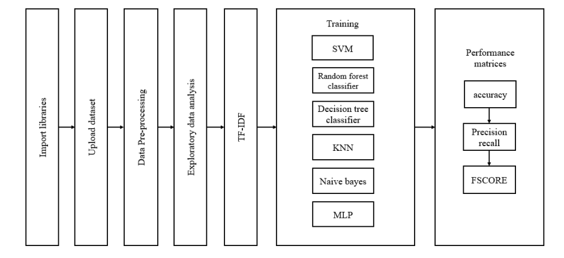
Fig. 1: Block diagram of proposed system
Applications
- Fraud Detection
- Job Seeker Protection
- Trust Building
- Platform Moderation
- Compliance with Employment Regulations
- Reputation Management
- Data Analysis and Insights

CHAPTER 4
SOFTWARE AND HARDWARE REQUIRMENT
4.1 HARDWARE REQUIREMENTS:
- System : Pentium Dual Core.
- Hard Disk : 120 GB.
- Monitor : 15’’ LED
- Input Devices : Keyboard, Mouse
- Ram : 4 GB
4.2 SOFTWARE REQUIREMENTS:
- Operating system : Windows 10
- Coding Language : python
- Tool : Python
- Database : dataset
- Server : Flask
4.3 Hardware Interfaces
Intel Core i5 2.00GHz Processor or each and every other processor and 200 GB min RAM 20GB Hard plate, and mouse is required.
Software Interfaces
The Python IDLE is an open-supply web utility that allows you to make and charge records that be essential for stay code, circumstances, portrayals, and story-printed content. Uses encompass realities cleansing and exchange, numerical re-establishment, quantifiable illustrating, realities conviction, framework examining, and divides
CHAPTER 5
RESULT
Double click the "run.bat" file to run the project and get the below screen,
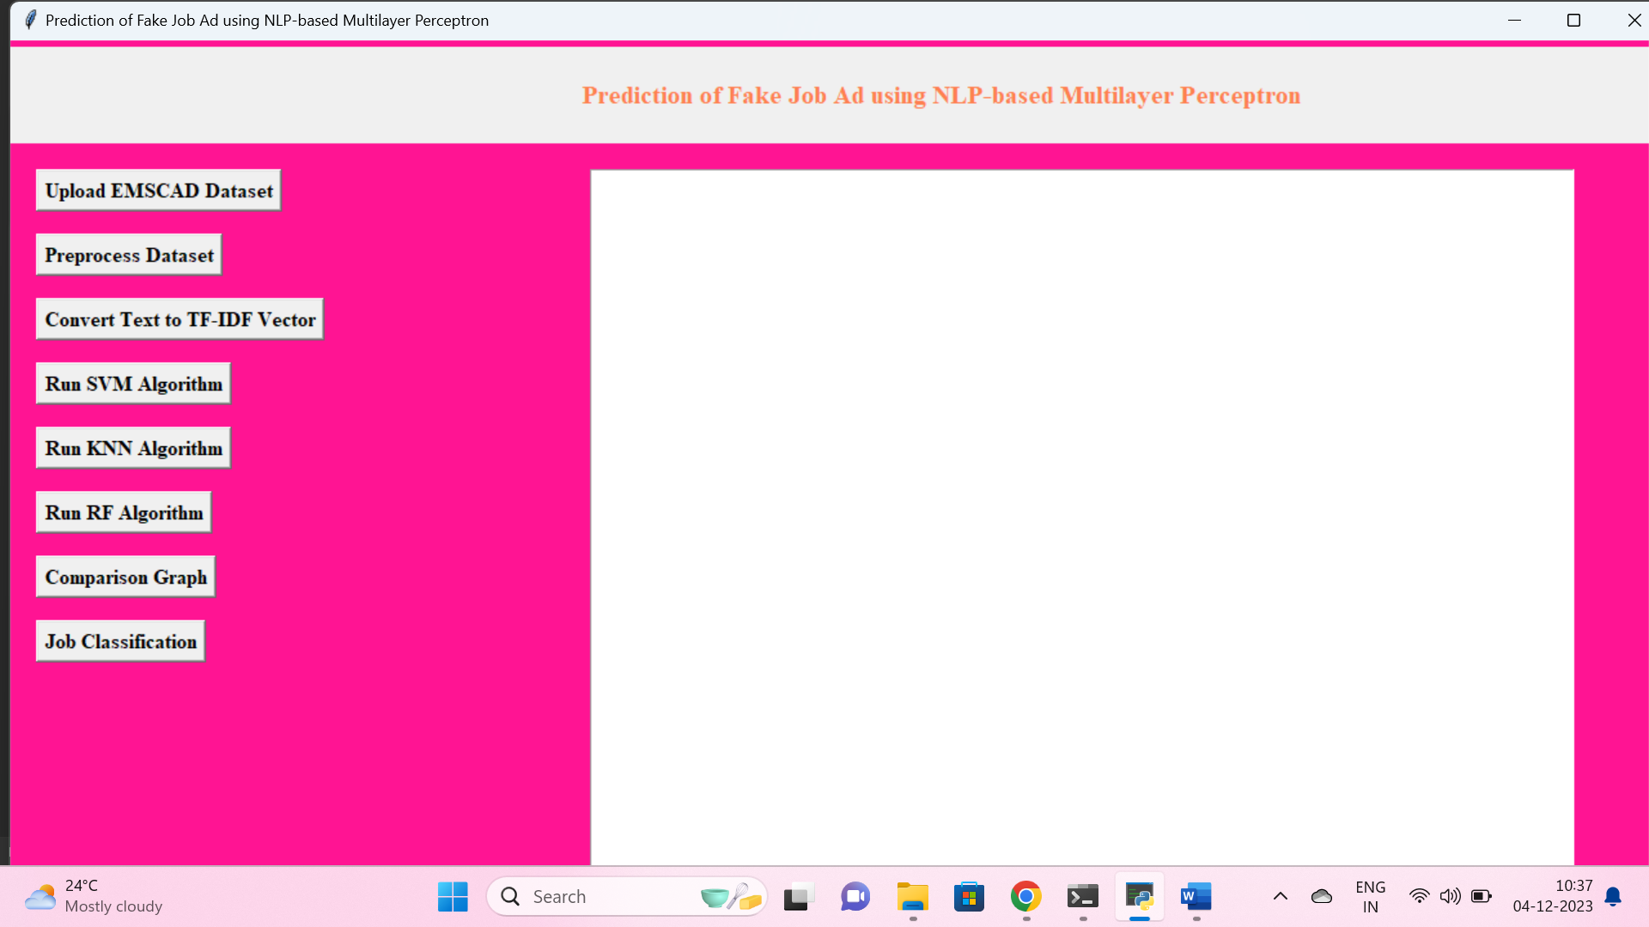
Fig.2 Run.bat file
On the above screen, to upload the dataset click on the ‘EMSCAD Dataset’ button and to get to the below screen,
Select and upload the ‘EMSCAD dataset, in the above screen, and to load the dataset then click on the ‘Open’ button. To get the below screen,
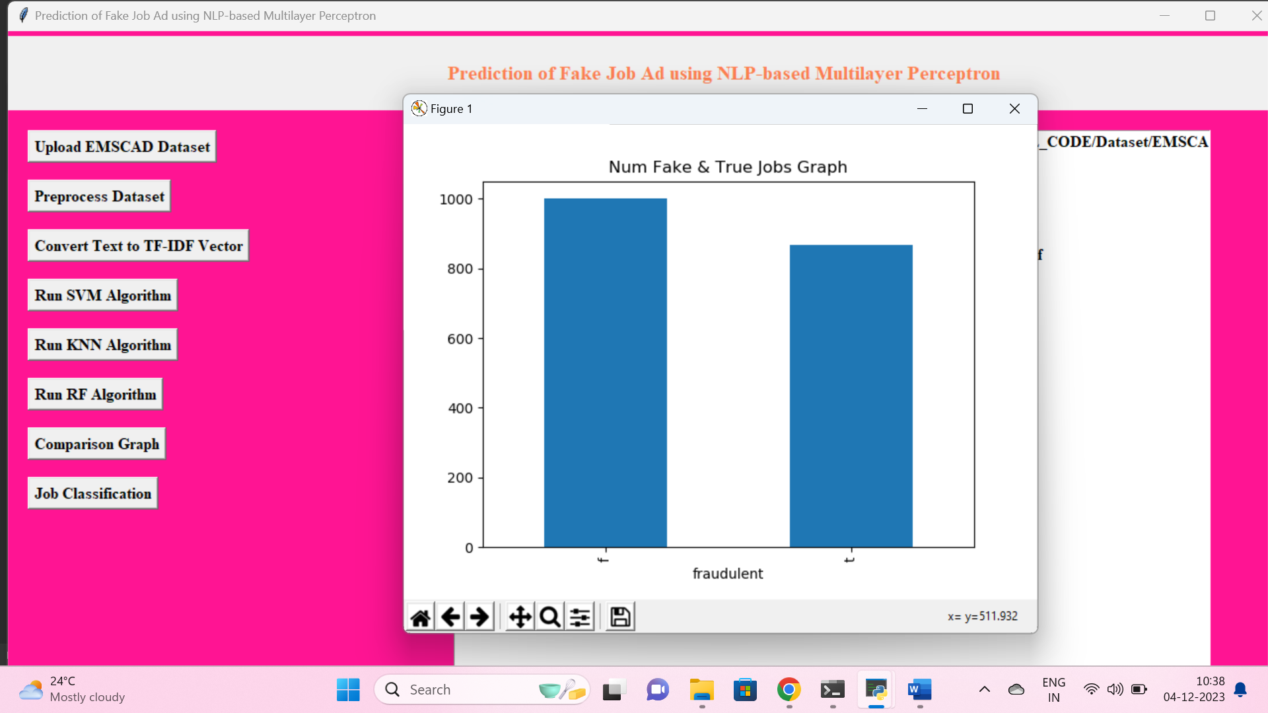
Fig.3 num fake and true jobs graph
Select and upload the ‘EMSCAD dataset, in the above screen, and to load the dataset then click on the ‘Open’ button. We can see the num fake and true jobs graph,

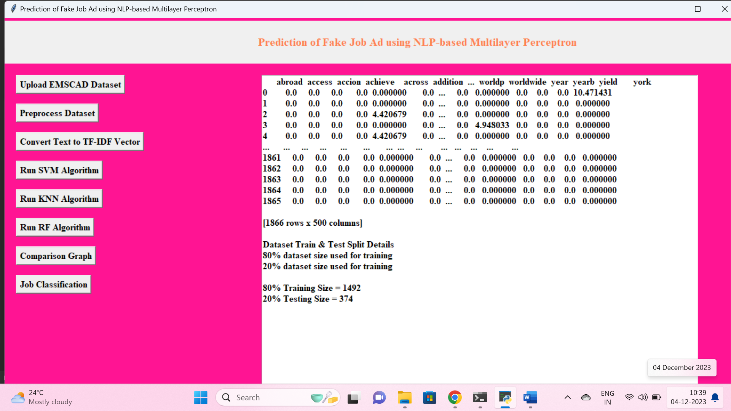
Fig.4 Pre-process dataset
I am displaying few records from dataset and in above dataset we can see some values are non-numeric and machine learning will not accept non-numeric values so we need to preprocess those values to assign integer id to each unique non-numeric value
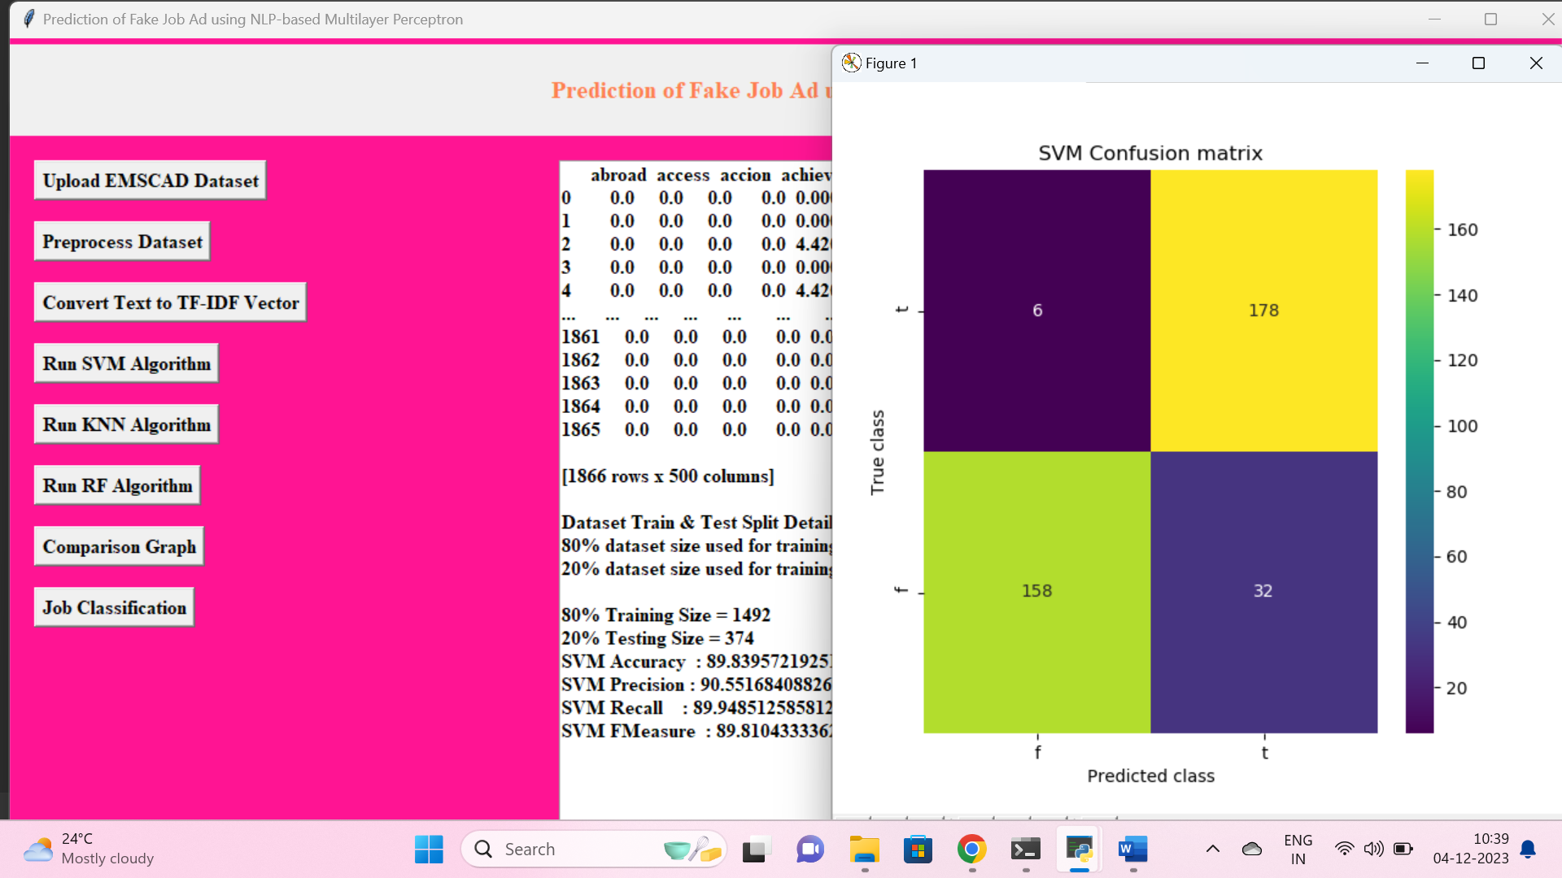
Fig.5. confusion matrix for support vector machine
Click on the run svm In the above screen we can get the confusion matrix for support vector machine,
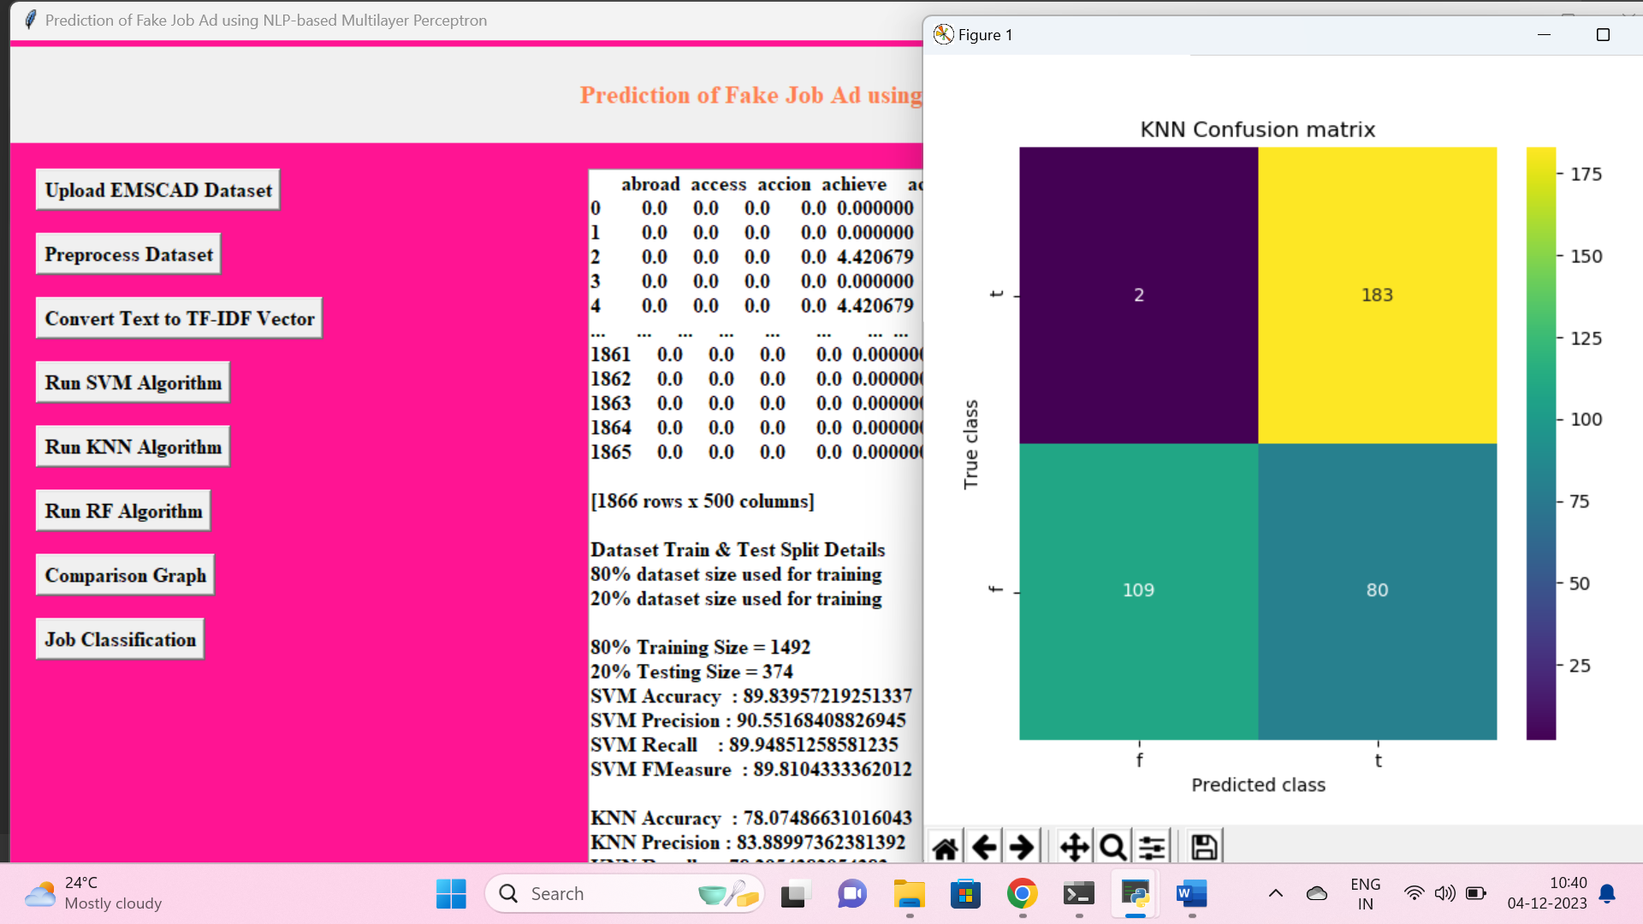
Fig.6. confusion matrix for KNN
Similarly Click on the run KNN In the above screen we can get the confusion matrix for KNN,
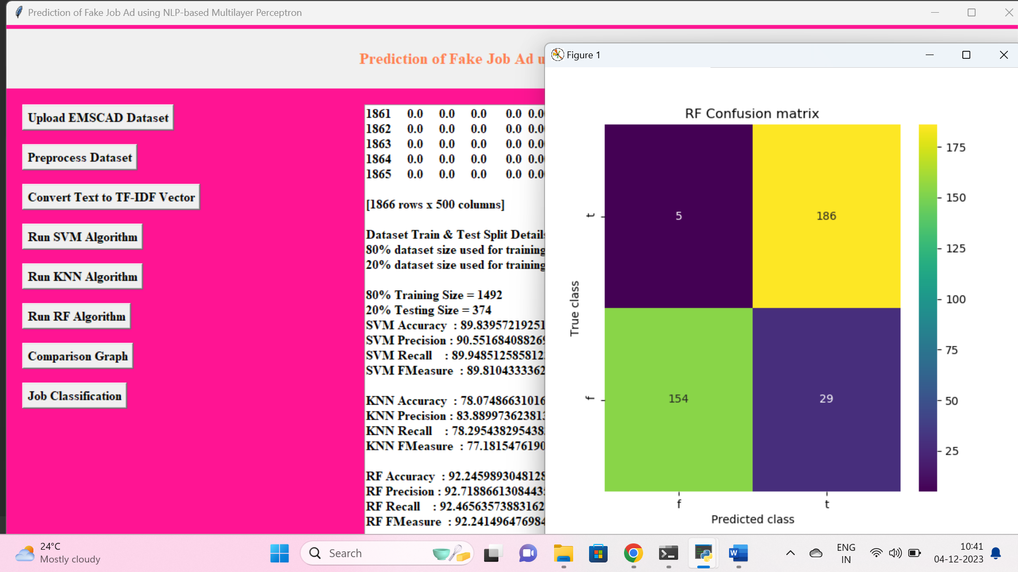
Fig.7. confusion matrix for RF
Similarly Click on the run RF In the above screen we can get the confusion matrix for RF,
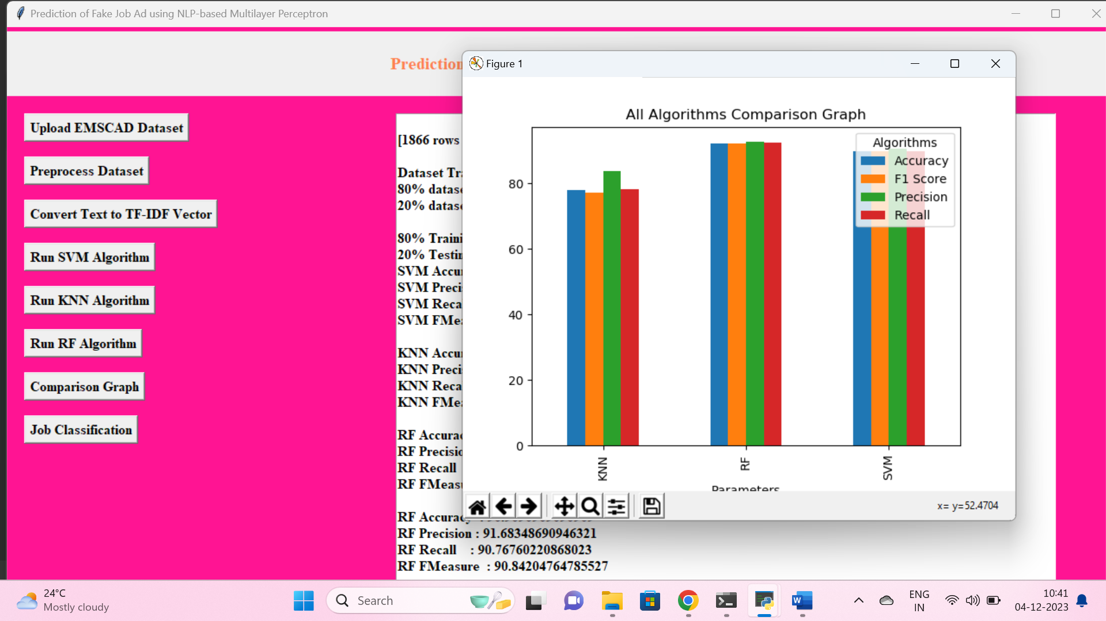
Fig.7. comparison graph
In above screen we can the comparison graph for all algorithms and below screen we can see the job description
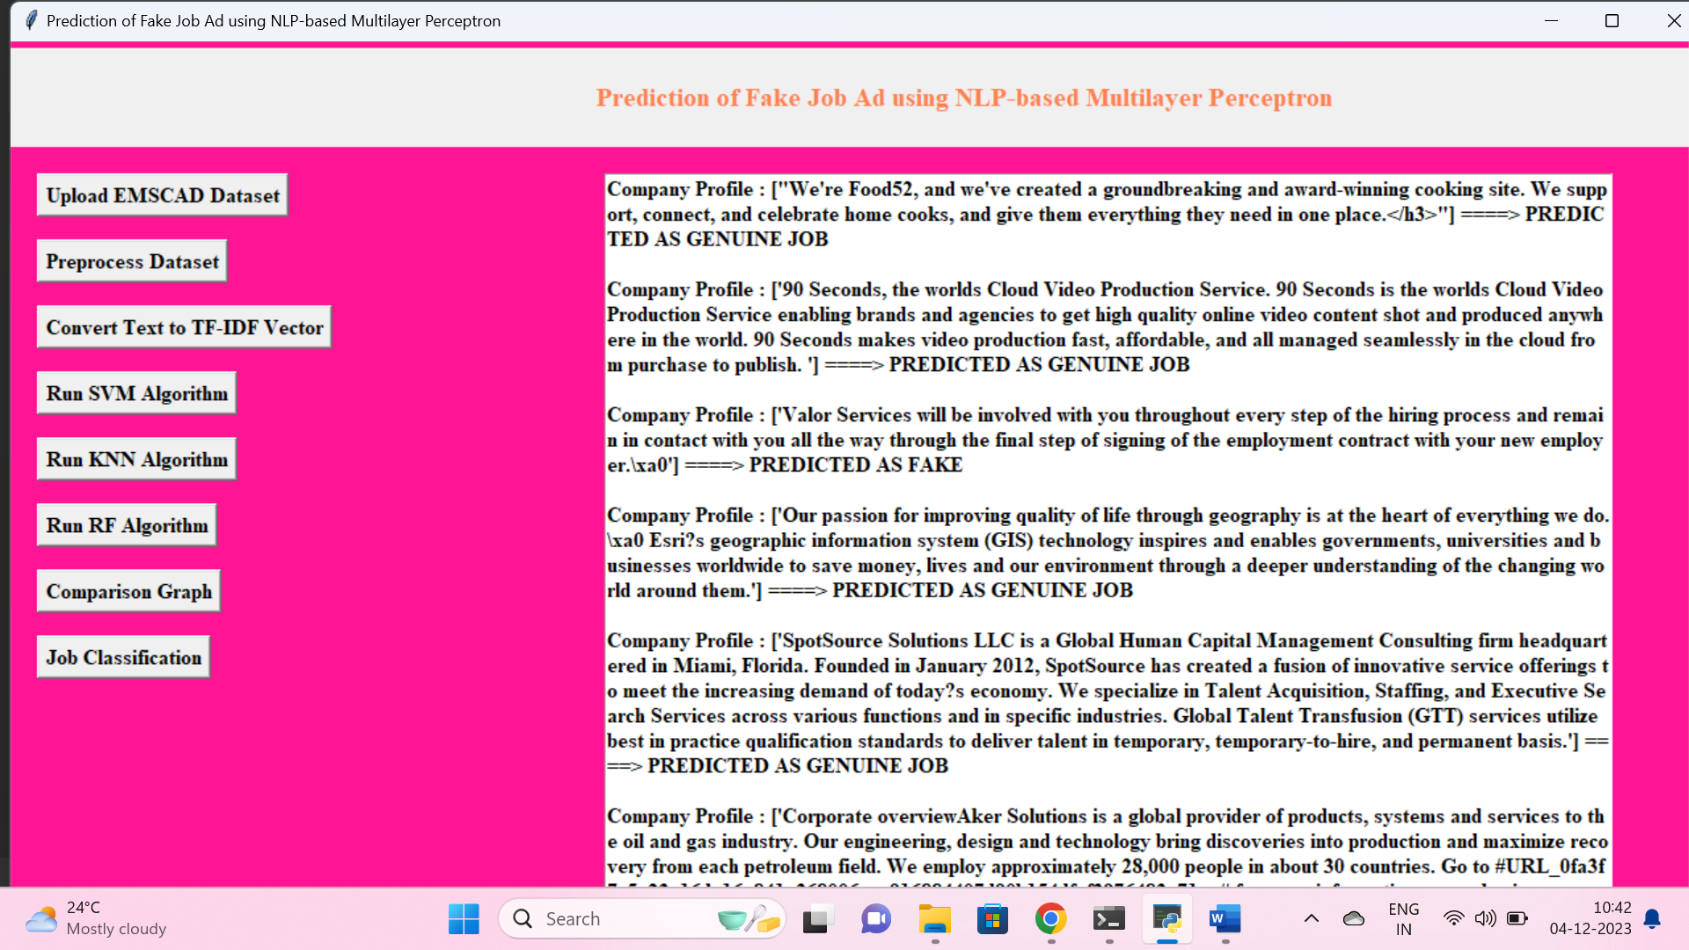
Fig.8. job description

CHAPTER 6
CONCLUSION
Job scam detection has become a great concern all over the world at present. In this project, we have analyzed the impacts of job scam which can be a very prosperous area in research filed creating a lot of challenges to detect fraudulent job posts. We have experimented with EMSCAD dataset which contains real life fake job posts. In this paper, we have experimented both machine learning algorithms SVM, KNN, Naive Bayes, Random Forest and a neural network concept called MLP. This work shown the evaluation of machine learning and MLP-based classifiers.

REFERENCE
[1] S. Vidros, C. Kolias, G. Kambourakis, and L. Akoglu, “Automatic Detection of Online Recruitment Frauds: Characteristics, Methods, and a Public Dataset”, Future Internet 2017, 9, 6; doi:10.3390/fi9010006.
[2] B. Alghamdi, F. Alharby, “An Intelligent Model for Online Recruitment Fraud Detection”, Journal of Information Security, 2019, Vol 10, pp. 155-176, https://doi.org/10.4236/iis.2019.103009.
[3] Tin Van Huynh1, Kiet Van Nguyen, Ngan Luu-Thuy Nguyen1, and Anh Gia-Tuan Nguyen, “Job Prediction: From Deep Neural Network Models to Applications”, RIVF International Conference on Computing and Communication Technologies (RIVF), 2020.
[4] Jiawei Zhang, Bowen Dong, Philip S. Yu, “FAKEDETECTOR: Effective Fake News Detection with Deep Diffusive Neural Network”, IEEE 36th International Conference on Data Engineering (ICDE), 2020.
[5] B. Alghamdi and F. Alharby, ―An Intelligent Model for Online Recruitment Fraud Detection,” J. Inf. Secur., vol. 10, no. 03, pp. 155–176, 2019, doi: 10.4236/jis.2019.103009
[6] S. U. Habiba, M. K. Islam and F. Tasnim, "A Comparative Study on Fake Job Post Prediction Using Different Data Mining Techniques," 2021 2nd International Conference on Robotics, Electrical and Signal Processing Techniques (ICREST), 2021, pp. 543-546, doi: 10.1109/ICREST51555.2021.9331230.
[7] Amaar, A., Aljedaani, W., Rustam, F. et al. Detection of Fake Job Postings by Utilizing Machine Learning and Natural Language Processing Approaches. Neural Process Lett 54, 2219–2247 (2022). https://doi.org/10.1007/s11063-021-10727-z
[8] Mehboob, A., Malik, M.S.I. Smart Fraud Detection Framework for Job Recruitments. Arab J Sci Eng 46, 3067–3078 (2021). https://doi.org/10.1007/s13369-020-04998-2
[9] D. Ranparia, S. Kumari and A. Sahani, "Fake Job Prediction using Sequential Network," 2020 IEEE 15th International Conference on Industrial and Information Systems (ICIIS), 2020, pp. 339-343, doi: 10.1109/ICIIS51140.2020.9342738.
[10] Sudhakar, M., Kaliyamurthie, K.P. (2023). Efficient Prediction of Fake News Using Novel Ensemble Technique Based on Machine Learning Algorithm. In: Kaiser, M.S., Xie, J., Rathore, V.S. (eds) Information and Communication Technology for Competitive Strategies (ICTCS 2021). Lecture Notes in Networks and Systems, vol 401. Springer, Singapore. https://doi.org/10.1007/978-981-19-0098-3_1

APPENDIX
PYTHON
1.1 Introduction
* One of the most popular languages is Python. Guido van Rossum released this language in 1991. Python is available on the Mac, Windows, and Raspberry Pi operating systems. The syntax of Python is simple and identical to that of English. When compared to Python, it was seen that the other language requires a few extra lines.
*It is an interpreter-based language because code may be run line by line after it has been written. This implies that rapid prototyping is possible across all platforms. Python is a big language with a free, binary-distributed interpreter standard library.
* It is inferior to maintenance that is conducted and is straightforward to learn. It is an object-oriented, interpreted programming language. It supports several different programming paradigms in addition to object-oriented programming, including functional and procedural programming.
* It supports several different programming paradigms in addition to object-oriented programming, including practical and procedural programming. Python is mighty while maintaining a relatively straightforward syntax. Classes, highly dynamic data types, modules, and exceptions are covered. Python can also be utilised by programmes that require programmable interfaces as an external language.
Here are some key features and characteristics of Python:
- Readability: Python emphasizes code readability with its clean and intuitive syntax. It uses indentation and whitespace to structure code blocks, making it easy to understand and maintain.
- Easy to Learn: Python's simplicity and readability make it an excellent choice for beginners. Its straightforward syntax and extensive documentation make it accessible for newcomers to programming.
- Interpreted Language: Python is an interpreted language, meaning that it doesn't need to be compiled before running. The Python interpreter reads and executes the code directly, making the development process faster and more interactive.
- Cross-platform Compatibility: Python is available for major operating systems like Windows, macOS, and Linux. This cross-platform compatibility allows developers to write code once and run it on different platforms without modifications.
- Large Standard Library: Python comes with a vast standard library that provides ready-to-use modules and functions for various tasks. It covers areas such as file I/O, networking, regular expressions, databases, and more, saving developers time and effort.
- Extensible and Modular: Python supports modular programming, enabling developers to organize code into reusable modules and packages. Additionally, Python allows integrating modules written in other languages, such as C or C++, providing flexibility and performance optimizations.
- Wide Range of Libraries and Frameworks: Python has a vibrant ecosystem with numerous third-party libraries and frameworks. These libraries, such as NumPy, pandas, TensorFlow, and Django, extend Python's capabilities for specific domains, making it a powerful tool for diverse applications.
- Object-Oriented: Python supports object-oriented programming (OOP) principles, allowing developers to create and work with classes and objects. OOP provides a structured approach to code organization, promoting code reuse and modularity.
- Dynamic Typing: Python is dynamically typed, meaning variable types are determined at runtime. Developers do not need to declare variable types explicitly, which enhances flexibility and simplifies code writing.
1.2 Installation
To install Python on your computer, follow these basic steps:
- Step 1: Visit the Python website Go to the official Python website at https://www.python.org/.
- Step 2: Select the operating system Choose the appropriate installer for your operating system. Python supports Windows, macOS, and various Linux distributions. Make sure to select the correct version that matches your operating system.
- Step 3: Check which version of Python is installed; if the 3.7.0 version is not there, uninstall it through the control panel and
- Step 4: Install Python 3.7.0 using Cmd.
- Step 5: Install the all libraries that required to run the project
- Step 6: Run
1.3 Python Features:
- Easy: Because Python is a more accessible and straightforward language, Python programming is easier to learn.
- Interpreted language: Python is an interpreted language, therefore it can be used to examine the code line by line and provide results.
- Open Source: Python is a free online programming language since it is open-source.
- Portable: Python is portable because the same code may be used on several computer standard
- libraries: Python offers a sizable library that we may utilize to create applications quickly.
- GUI: It stands for GUI (Graphical User Interface)
- Dynamical typed: Python is a dynamically typed language, therefore the type of the value will be determined at runtime.
1.4 Python GUI (Tkinter)
- Python provides a wide range of options for GUI development (Graphical User Interfaces).
- Tkinter, the most widely used GUI technique, is used for all of them.
- The Tk GUI toolkit offered by Python is used with the conventional Python interface.
- Tkinter is the easiest and quickest way to write Python GUI programs.
- Using Tkinter, creating a GUI is simple.
- A part of Python's built-in library is Tkinter. The GUI programs were created.
- Python and Tkinter together give a straightforward and quick way. The Tk GUI toolkit's object-oriented user interface is called Tkinter.
Making a GUI application is easy using Tkinter. Following are the steps:
1) Install the Tkinter module in place.
2) The GUI applicatioMakeske the primary window
3) Include one or more of the widgets mentioned above in the GUI application.
4) Set up the main event loop such that it reacts to each user-initiated event.
Although Tkinter is the only GUI framework included in the Python standard library, Python includes a GUI framework. The default library for Python is called Tkinter. Tk is a scripting language often used in designing, testing, and developing GUIs. Tk is a free, open-source widget toolkit that may be used to build GUI applications in a wide range of computer languages.
1.5 Python IDLE
- Python IDLE offers a full-fledged file editor, which gives you the ability to write and execute Python programs from within this program. The built-in file editor also includes several features, like code completion and automatic indentation, that will speed up your coding workflow.
- Guido Van Rossum named Python after the British comedy group Monty Python while the name IDLE was chosen to pay tribute to Eric Idle, who was one of the Monty Python's founding members. IDLE comes bundled with the default implementation of the Python language since the 01.5. 2b1 release
- IDLE is used to execute statements similar to Python Shell. IDLE is used to create, modify, and execute Python code. IDLE provides a fully-featured text editor to write Python scripts and provides features like syntax highlighting, auto-completion, and smart indent.
- IDLE has two modes: interactive and script. We wrote our first program, “Hello, World!” in interactive mode. Interactive mode immediately returns the results of commands you enter into the shell. In script mode, you will write a script and then run it.
- The IDE Python IDLE is a good place to start as it helps you become familiar with the way Python works and understand its syntax. This IDE is good to start programming in Python due to its great debugger, but once you are fluent and start developing projects it is necessary to jump to another, more complete IDE.
- Python IDLE (Integrated Development and Learning Environment) is an interactive development environment included with the Python programming language. It provides a convenient way to write, execute, and debug Python code.
When you install Python, IDLE is typically installed along with it. To open IDLE, you can follow these steps:
- Open the command prompt (Windows) or terminal (macOS/Linux).
- Type "idle" and press Enter. Alternatively, you can specify the version with "idle3" or "idle2" for Python 3 or Python 2, respectively.
- Once IDLE is launched, you will see the Python shell, which is an interactive environment where you can type and execute Python code directly.
Here are some features and functionalities provided by Python IDLE:
- Editor: IDLE includes a text editor where you can write your Python code. It offers syntax highlighting, automatic indentation, and code completion to enhance your coding experience.
- Interactive Shell: The Python shell in IDLE allows you to execute Python code interactively. You can type commands, statements, or function calls directly in the shell, and Python will execute them immediately.
- Debugging: IDLE provides basic debugging capabilities to help you find and fix errors in your code. You can set breakpoints, step through code, inspect variables, and track the program's execution.
- Python Help: IDLE provides access to the Python documentation and built-in help. You can access the help menu to find information about Python modules, functions, classes, and more.
- Script Execution: In addition to the interactive shell, IDLE allows you to run Python scripts stored in files. You can write your code in the editor and execute it as a script to see the output or interact with the program.
- Customization: IDLE can be customized to suit your preferences. You can modify settings related to syntax highlighting, indentation, fonts, and more.
- Python IDLE serves as a beginner-friendly development environment and learning tool. It is suitable for writing small scripts, testing code snippets, experimenting with Python features, and learning the language's basics. However, for more advanced development projects, you may consider using other code editors or integrated development environments (IDEs) that provide additional features and better project management capabilities.
1.6 Libraries
In Python, libraries (also referred to as modules or packages) are collections of pre-written code that provide additional functionality and tools to extend the capabilities of the Python language. Libraries contain reusable code that developers can leverage to perform specific tasks without having to write everything from scratch.
Python libraries are designed to solve common problems, such as handling data, performing mathematical operations, interacting with databases, working with files, implementing networking protocols, creating graphical user interfaces (GUIs), and much more. They provide ready-to-use functions, classes, and methods that simplify complex operations and save development time.
Libraries in Python offer various advantages:
- Code Reusability:
- Efficiency:
- Collaboration
- Domain-Specific Functionality
- To use a Python library, you need to install it first.
There are some libraries following:
- Pandas:
Pandas are a Python computer language library for data analysis and manipulation. It offers a specific operation and data format for handling time series and numerical tables. It differs significantly from the release3-clause of the BSD license. It is a well-liked open-source of opinion that is utilized in machine learning and data analysis.
Pandas are a Python package providing fast, flexible, and expressive data structures designed to make working with “relational” or “labeled” data both easy and intuitive. It aims to be the fundamental high-level building block for doing practical, real-world data analysis in Python. Pandas are a Python library used for working with data sets.
- It has functions for analysing, cleaning, exploring, and manipulating data.
- The name "Pandas" has a reference to both "Panel Data", and "Python Data Analysis" and was created by Wes McKinney in 2008.
- Pandas allow us to analyse big data and make conclusions based on statistical theories.
- Pandas can clean messy data sets, and make them readable and relevant.
Relevant data is very important in data science. Pandas are a Python library for data analysis. Started by Wes McKinney in 2008 out of a need for a powerful and flexible quantitative analysis tool, pandas have grown into one of the most popular Python libraries. It has an extremely active community of contributors. The name is derived from the term "panel data", an econometrics term for data sets that include observations over multiple time periods for the same individuals. Its name is a play on the phrase "Python data analysis" itself.
- NumPy:
The NumPy Python library for multi-dimensional, big-scale matrices adds a huge number of high-level mathematical functions. It is possible to modify NumPy by utilizing a Python library. Along with line, algebra, and the Fourier transform operations, it also contains several matrices-related functions.
NumPy can be used to perform a wide variety of mathematical operations on arrays. It adds powerful data structures to Python that guarantee efficient calculations with arrays and matrices and it supplies an enormous library of high-level mathematical functions that operate on these arrays and matrices.
- NumPy is a Python library used for working with arrays.
- It also has functions for working in domain of linear algebra, Fourier transform, and matrices.
- NumPy was created in 2005 by Travis Oliphant. It is an open source project and you can use it freely.
- NumPy stands for Numerical Python.
- In Python we have lists that serve the purpose of arrays, but they are slow to process.
- NumPy aims to provide an array object that is up to 50x faster than traditional Python lists.
- The array object in NumPy is called ndarray, it provides a lot of supporting functions that make working with ndarray very easy.
- Arrays are very frequently used in data science, where speed and resources are very important.

- Matplotlib:
It is a multi-platform, array-based data visualization framework built to interact with the whole SciPy stack. MATLAB is proposed as an open-source alternative. Matplotlib is a Python extension and a cross-platform toolkit for graphical plotting and visualization.
Matplotlib is a popular Python library for creating static, animated, and interactive visualizations. It provides a flexible and comprehensive set of tools for generating plots, charts, histograms, scatter plots, and more. Matplotlib is widely used in various fields, including data analysis, scientific research, and data visualization.
Here are some key features and functionalities of the Matplotlib library:
- Plotting Functions
- Customization Options
- Multiple Interfaces
- Integration with NumPy and pandas
- Subplots and Figures:
- Saving and Exporting
- Scikit-learn:
The most stable and practical machine learning library for Python is scikit-learn. Regression, dimensionality reduction, classification, and clustering are just a few of the helpful tools it provides through the Python interface for statistical modeling and machine learning. It is an essential part of the Python machine learning toolbox used by JP Morgan. It is frequently used in various machine learning applications, including classification and predictive analysis.
Scikit-learn (also referred to as sklearn) is a widely used open-source machine learning library for Python. It provides a comprehensive set of tools and algorithms for various machine learning tasks, including classification, regression, clustering, dimensionality reduction, model selection, and pre-processing.
Here are some key features and functionalities of the Scikit-learn library:
- Easy-to-Use Interface:
- Broad Range of Algorithms:
- Data Pre-processing and Feature Engineering:
- Model Evaluation and Validation:
- Integration with NumPy and pandas:
- Robust Documentation and Community Support:
- Keras:
* Google's Keras is a cutting-edge deep learning API for creating neural networks. It is created in Python and is designed to simplify the development of neural networks. Additionally, it enables the use of various neural networks for computation. Deep learning models are developed and tested using the free and open-source Python software known as Keras.
Keras is a high-level deep learning library for Python. It is designed to provide a user-friendly and intuitive interface for building and training deep learning models. Keras acts as a front-end API, allowing developers to define and configure neural networks while leveraging the computational backend engines, such as Tensor Flow or Theano.
Here are some key features and functionalities of the Keras library:
- User-Friendly API
- Multi-backend Support
- Wide Range of Neural Network Architectures
- Pre-trained Models and Transfer Learning:
- Easy Model Training and Evaluation:
- GPU Support:
- h5py:
* The h5py Python module offers an interface for the binary HDF5 data format. Thanks to p5py, the top can quickly halt the vast amount of numerical data and alter it using the NumPy library. It employs common syntax for Python, NumPy, and dictionary arrays.
h5py is a Python library that provides a simple and efficient interface for working with datasets and files in the Hierarchical Data Format 5 (HDF5) format. HDF5 is a versatile data format commonly used for storing and managing large volumes of numerical data.
Here are some key features and functionalities of the h5py library:
  - HDF5 File Access
  - Dataset Handling:
  - Group Organization:
  - Attributes:
  - Compatibility with NumPy
  - Performance
- Tensor flow
TensorFlow is a Python library for fast numerical computing created and released by Google. It is a foundation library that can be used to create Deep Learning models directly or by using wrapper libraries that simplify the process built on top of TensorFlow. TensorFlow is an end-to-end open source platform for machine learning. TensorFlow is a rich system for managing all aspects of a machine learning system; however, this class focuses on using a particular TensorFlow API to develop and train machine learning models.
TensorFlow is a popular open-source library for machine learning and deep learning. It provides a comprehensive set of tools, APIs, and computational resources for building and training various types of machine learning models, especially neural networks.
Here are some key features and functionalities of TensorFlow:
- Neural Network Framework:
- Computational Graphs
- Automatic Differentiation
- GPU and TPU Support
- Distributed Computing
- Deployment Capabilities
- Tkinter
Tkinter is an acronym for "Tk interface". Tk was developed as a GUI extension for the Tcl scripting language by John Ousterhout. The first release was in 1991. Tkinter is the de facto way in Python to create Graphical User interfaces (GUIs) and is included in all standard Python Distributions. In fact, it's the only framework built into the Python standard library.
Tkinter is a standard Python library used for creating graphical user interfaces (GUIs). It provides a set of modules and classes that allow you to develop interactive and visually appealing desktop applications.
Here are some key features and functionalities of Tkinter:
- Cross-Platform Compatibility
- Simple and Easy-to-Use
- Widgets and Layout Management
- Event-Driven Programming
- Customization and Styling
- Integration with Other Libraries
- NLTK
NLTK is a toolkit build for working with NLP in Python. It provides us various text processing libraries with a lot of test datasets. A variety of tasks can be performed using NLTK such as tokenizing, parse tree visualization, etc NLTK (Natural Language Toolkit) is the go-to API for NLP (Natural Language Processing) with Python. It is a really powerful tool to pre-process text data for further analysis like with ML models for instance. It helps convert text into numbers, which the model can then easily work with.
NLTK (Natural Language Toolkit) is a Python library widely used for working with human language data and implementing natural language processing (NLP) tasks. It provides a set of tools, corpora, and resources for tasks such as tokenization, stemming, tagging, parsing, sentiment analysis, and more.
Here are some key features and functionalities of NLTK:
- Text Processing
- Part-of-Speech Tagging
- Named Entity Recognition
- Chunking and Parsing
- Sentiment Analysis:
- WordNet Integration:
- Scipy
SciPy is a collection of mathematical algorithms and convenience functions built on the NumPy extension of Python. It adds significant power to the interactive Python session by providing the user with high-level commands and classes for manipulating and visualizing data.
SciPy is a powerful scientific computing library for Python that provides a wide range of mathematical algorithms and functions. It builds upon NumPy, another fundamental library for numerical computing, and extends its capabilities by adding additional tools for scientific and technical computing tasks.
Here are some key features and functionalities of SciPy:
- Numerical Integration:
- Optimization and Root Finding
- Linear Algebra
- Signal and Image Processing
- Statistics

